Adding a word to the dictionary

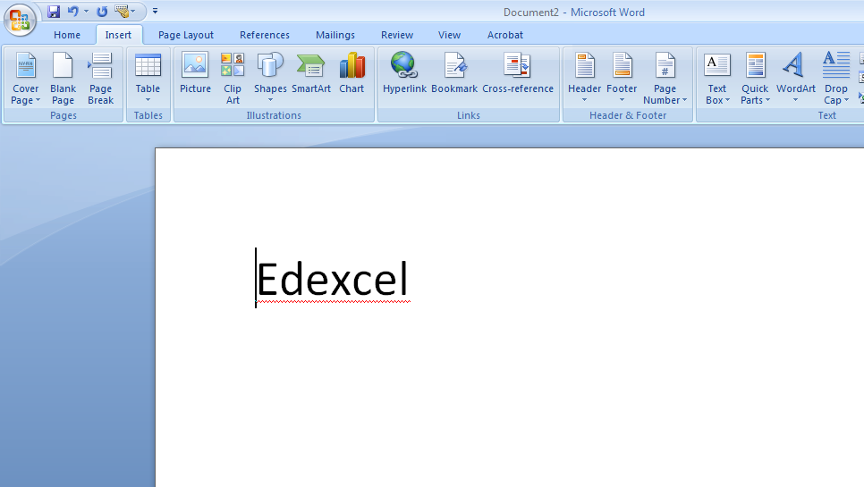

I want to add my name to the dictionary because it doesn’t recognize my name and there is a red line under.

The benefits of the Adding a word to the dictionary when you did any mistakes it will correct it for you

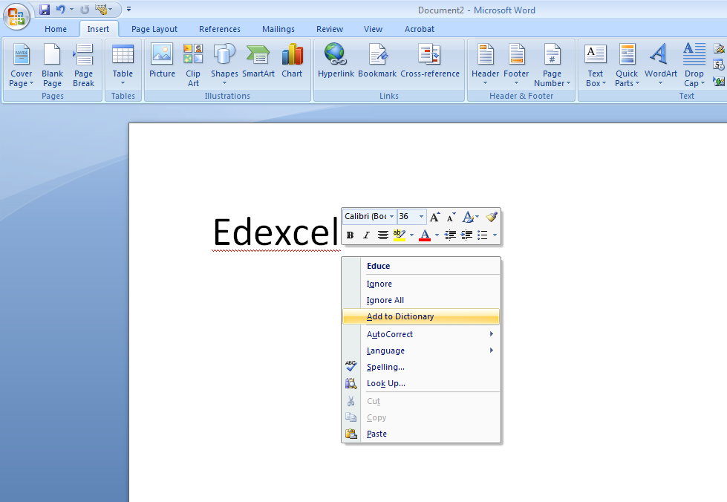

Right click on your name then click on Add to Dictionary

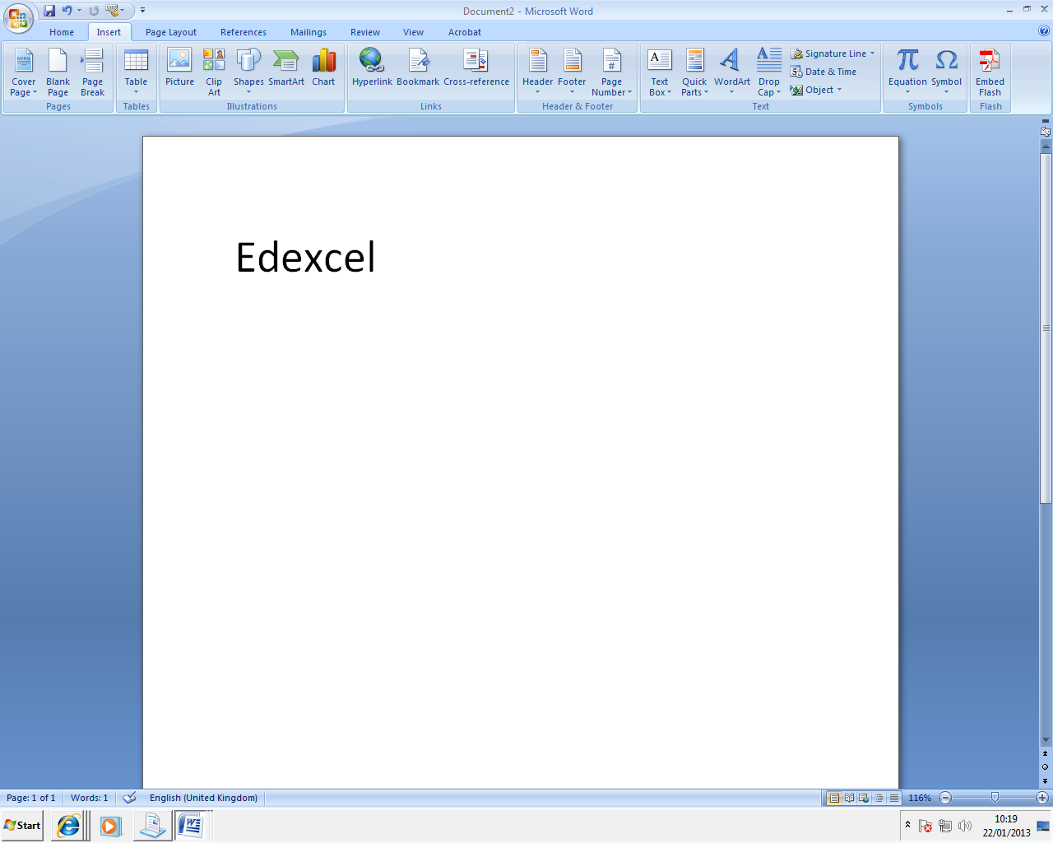
I added Edexcel to the dictionary and there is no red line under.

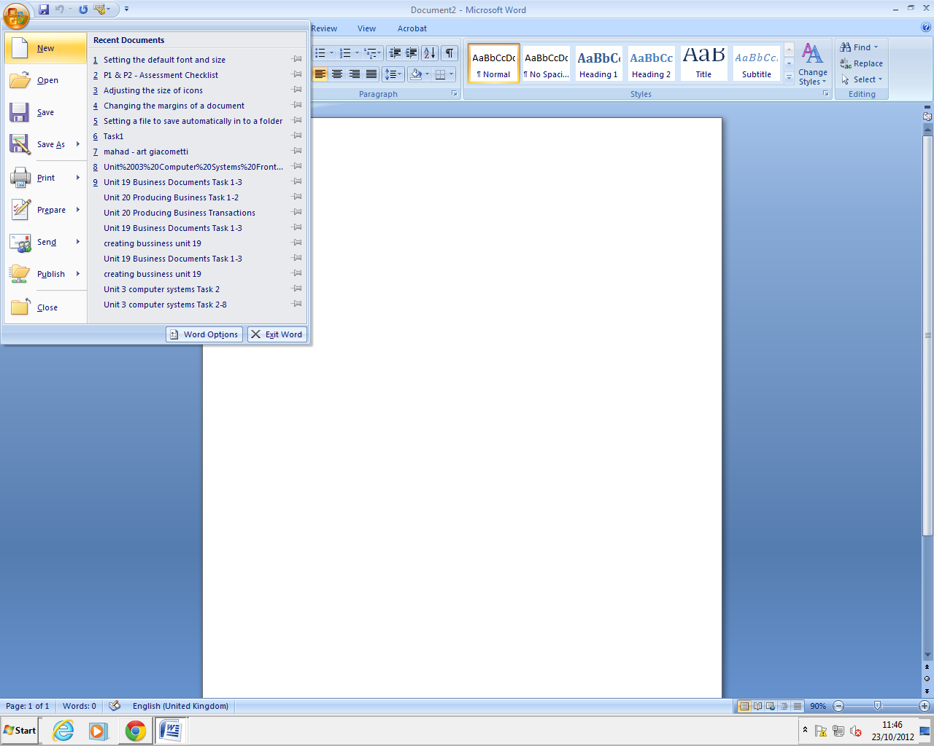
Setting the default font and size
The purpose of the” Setting the default font and size” is you can make your writing bigger or smaller, and also you can change the colour of your writing.

Click “New” on the Microsoft office button
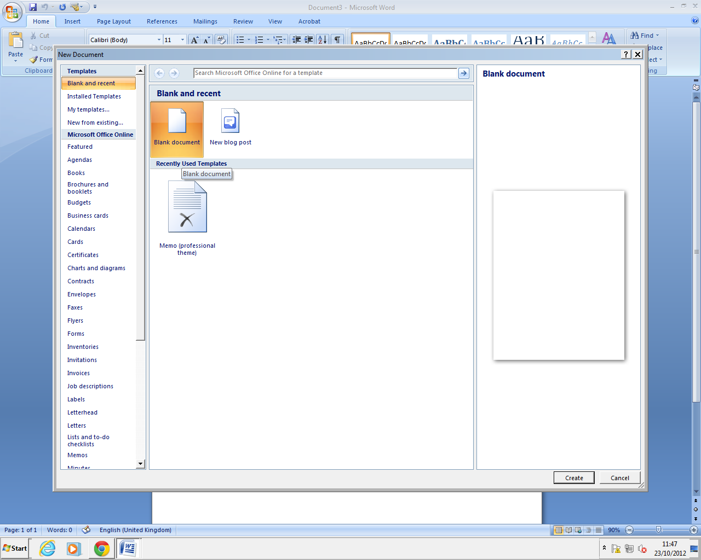
Press “Blank document” and then “Create”
Choose any attributes that you want and then click “Default”
A new word document was created. Now click on the “font” button
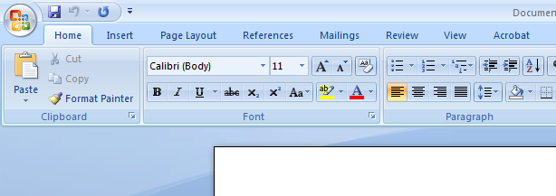

This is my default font and size, calibri 11

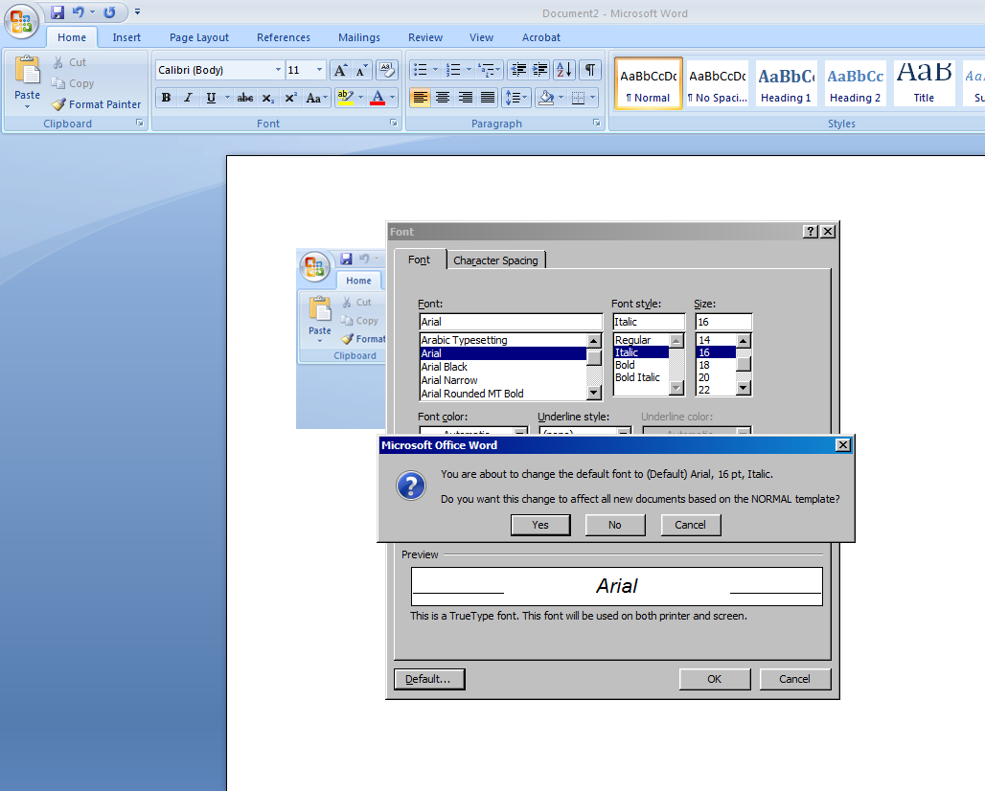

I want to make new default font and size, this time it will be Arial italic 16

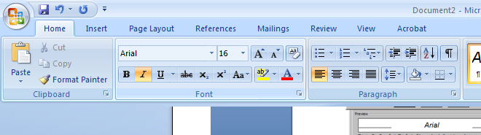

Here is my default font and size.

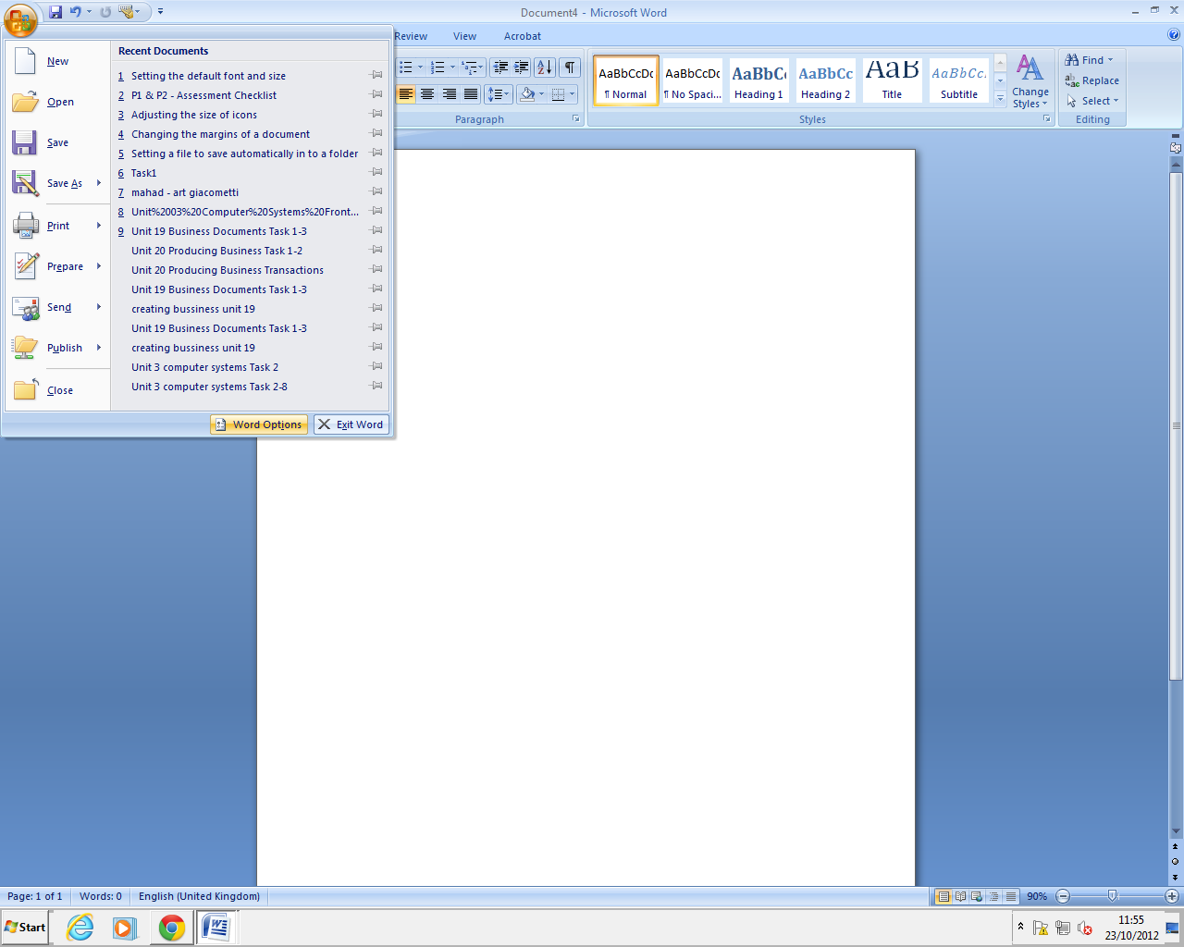
The benefit of auto text is that I can find the word I put on it much easier instead of writing it. I put Bile on the auto text because I use it a lot and the next time I can find it in auto text toolbar instead of writing it.

Adding an auto text entry
Click again on the Microsoft button and then “Word Options”
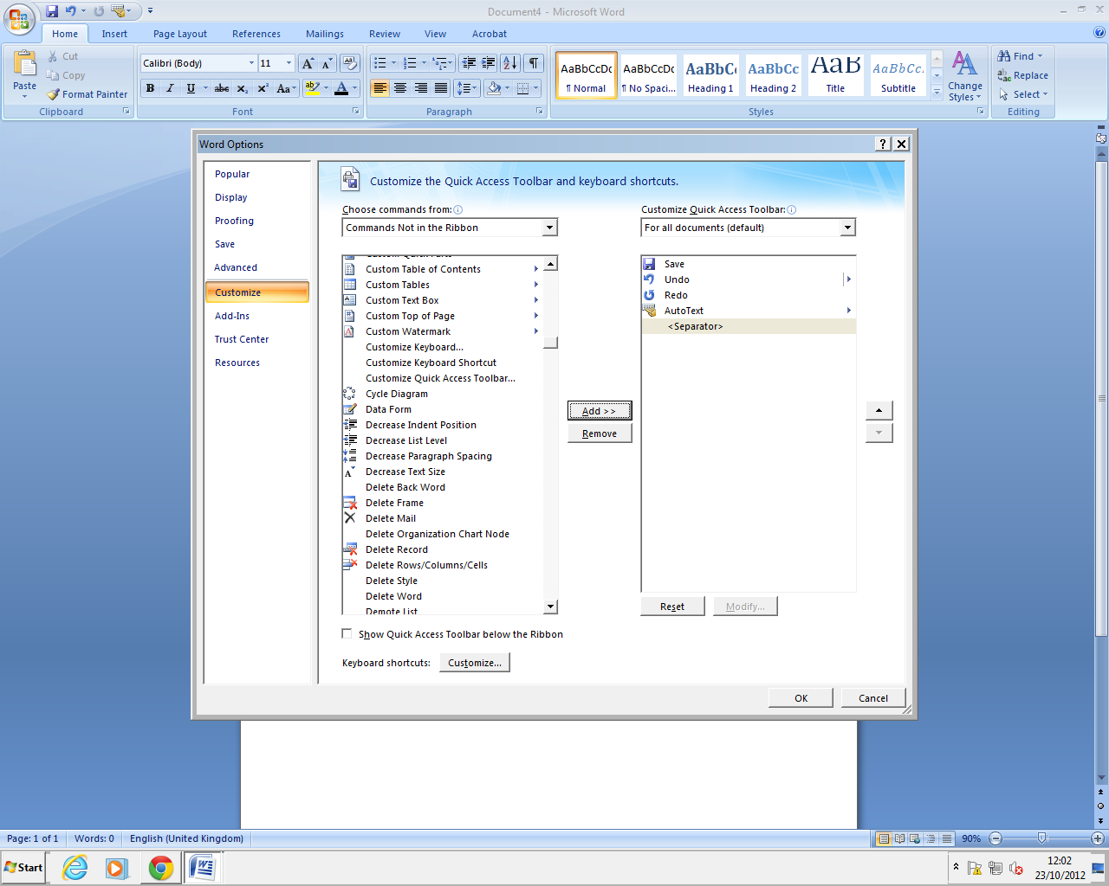
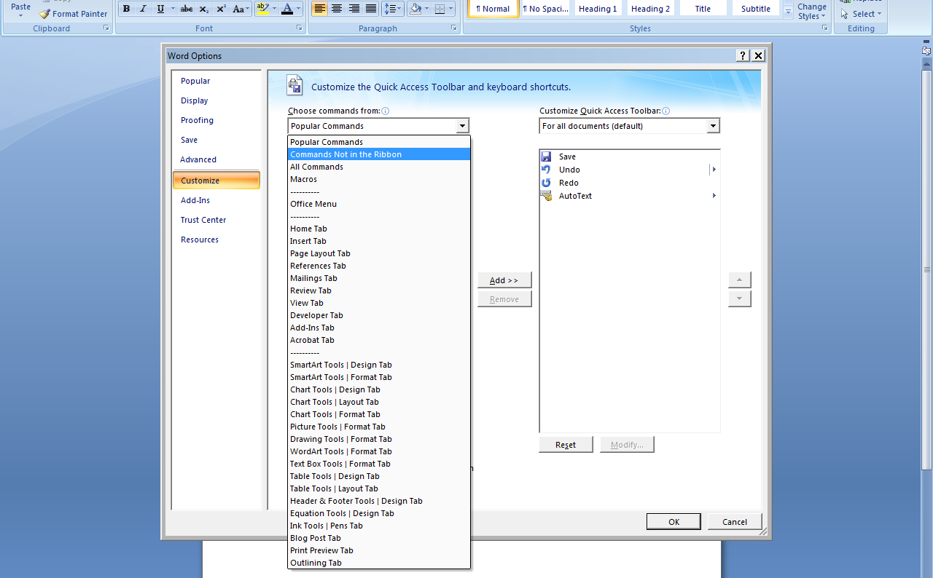
Click “Add” and then “OK”
In the “Customize” tab, select “Commands Not in the Ribbon” in the list.
I added the AutoText in to the Toolbar.
Open Microsoft button and click again on “Word Options”
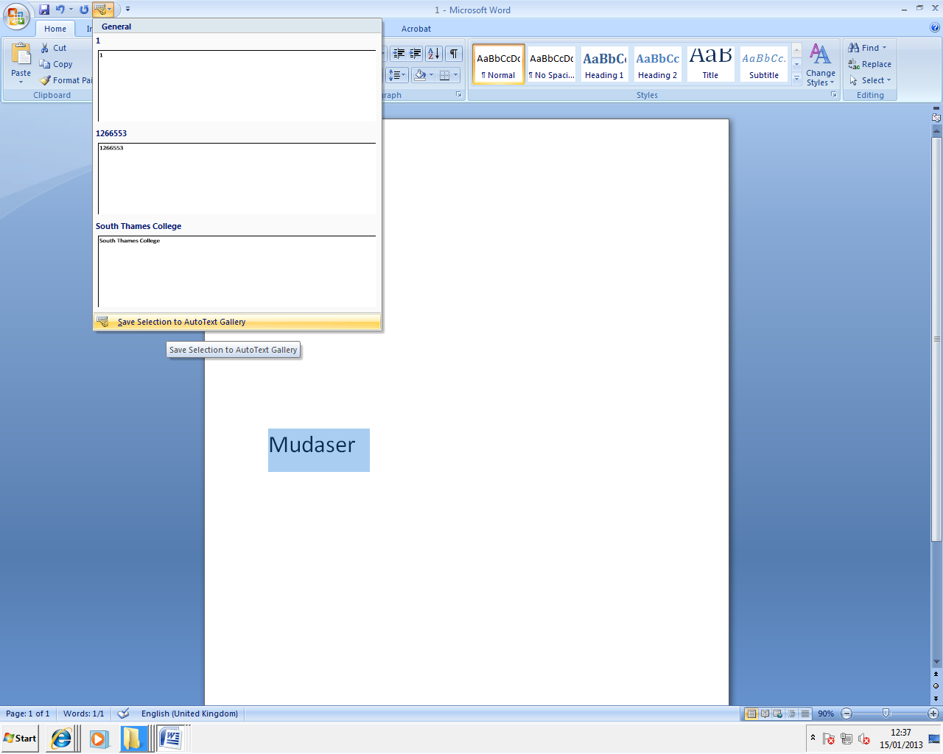
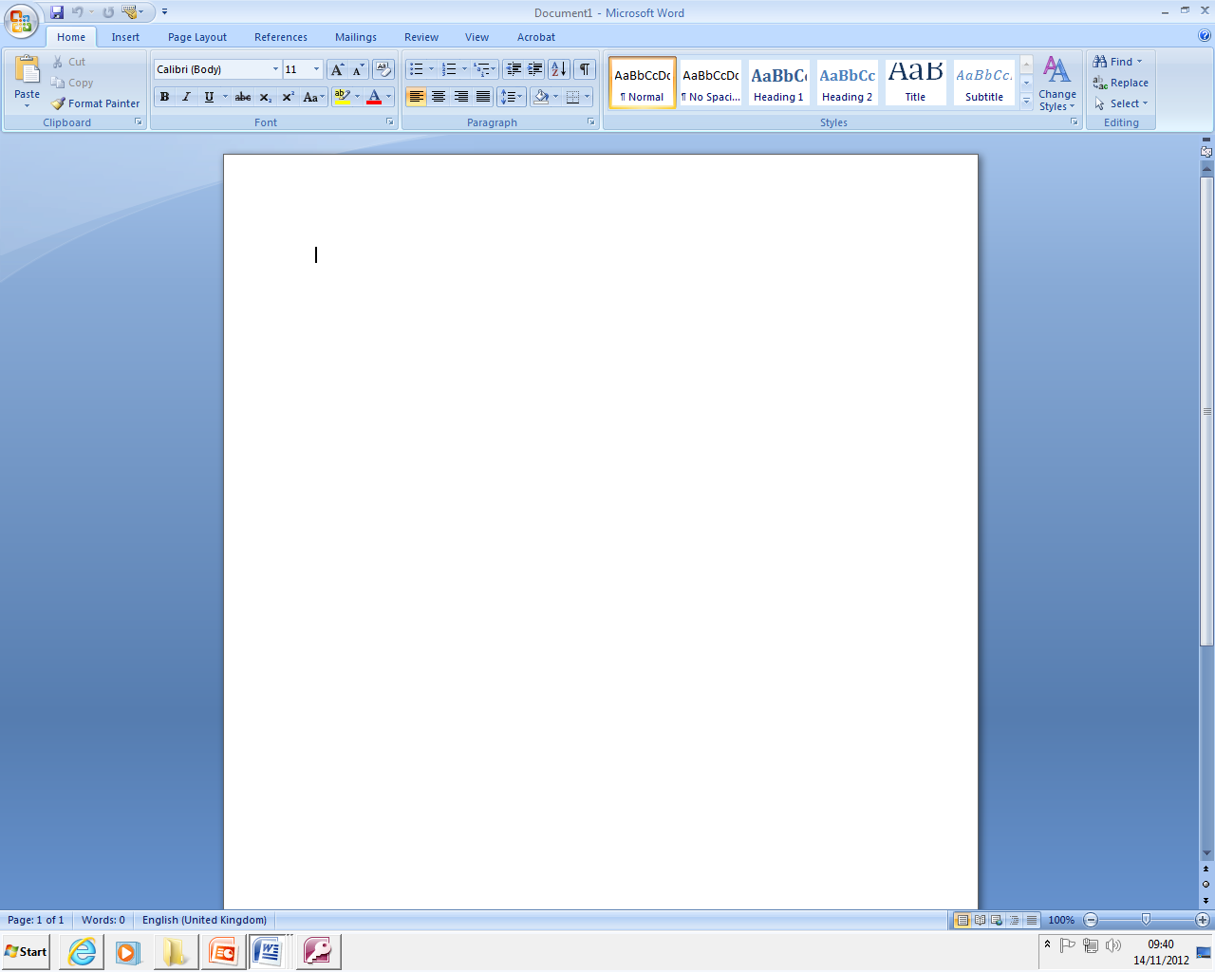

To save something in to the AutoText you need to highlight it, click on the AutoText and press “Save Selection to AutoText Gallery”.

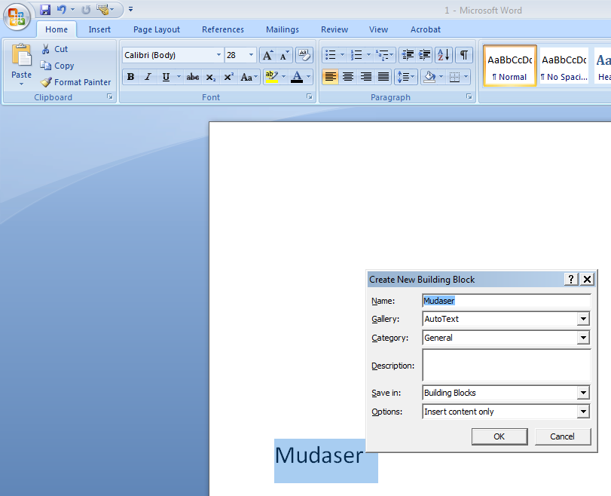

In here you can put description before pressing “OK”.

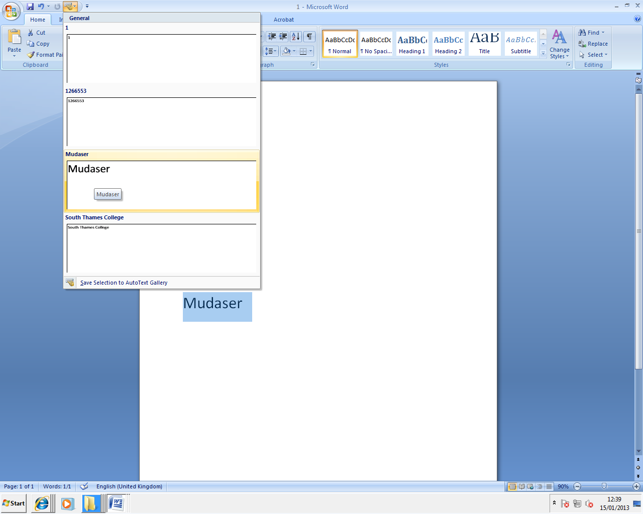
The new word is now saved in the AutoText gallery.

Click on “Office Button”

Adjusting the size of icons
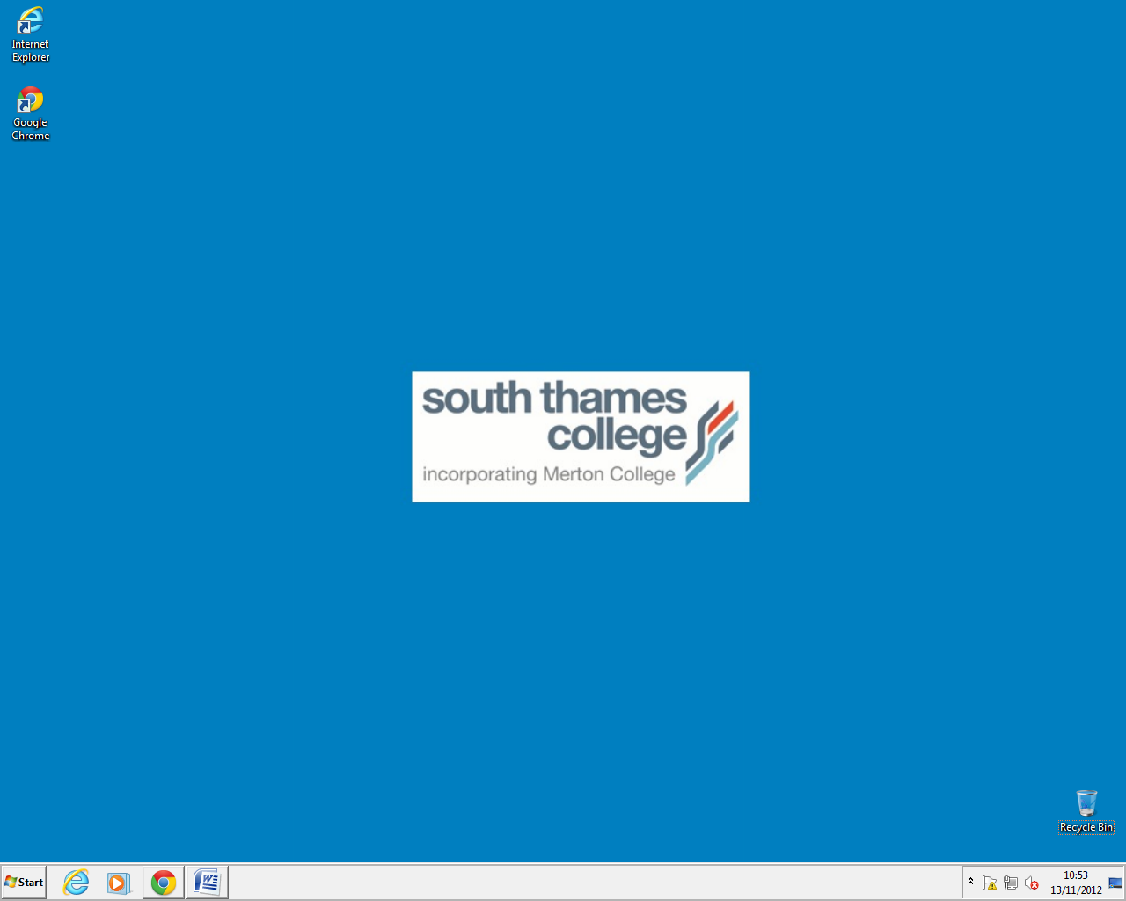
The benefit of changing the icons is that it will be easier for people that can’t see well to see it. I like it to be smaller because it will make it look better.

This is how the size of icons looks in the beginning

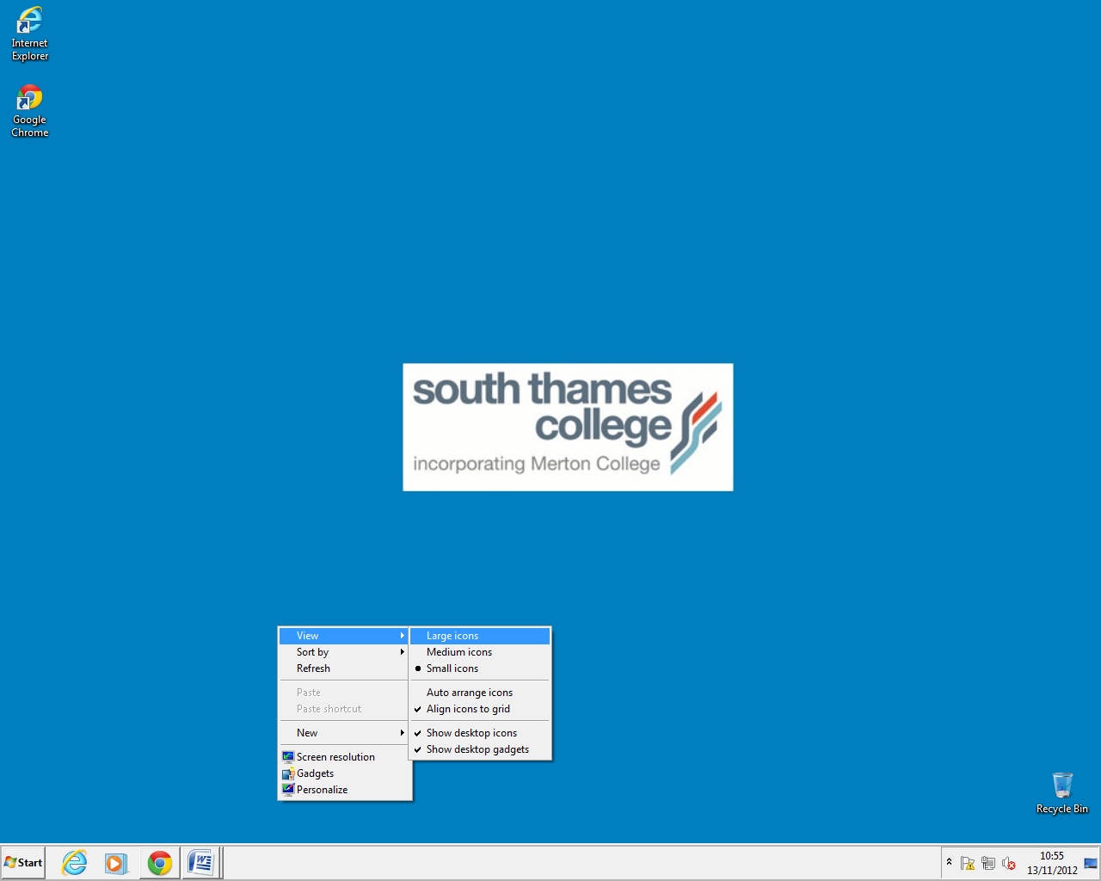
To change it, click right click, then “view” and then you can decide which one you want to chose. I’m going to choose the large icon.
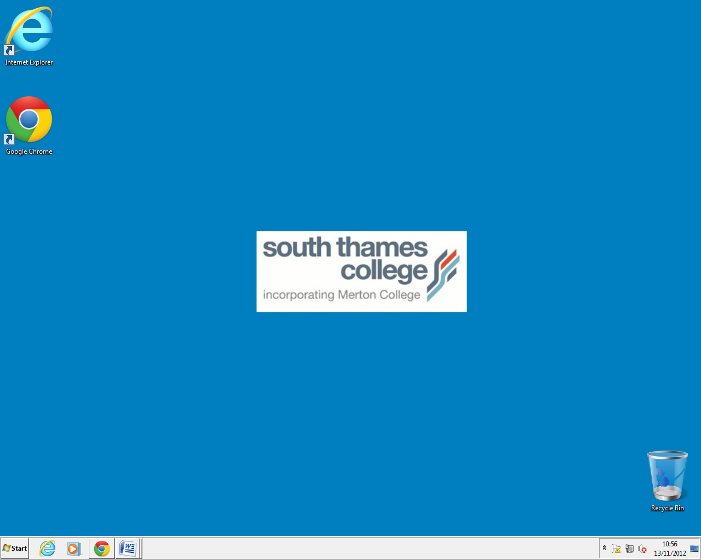
This is how it looked like after the changes were made.

Changing the margins of a document
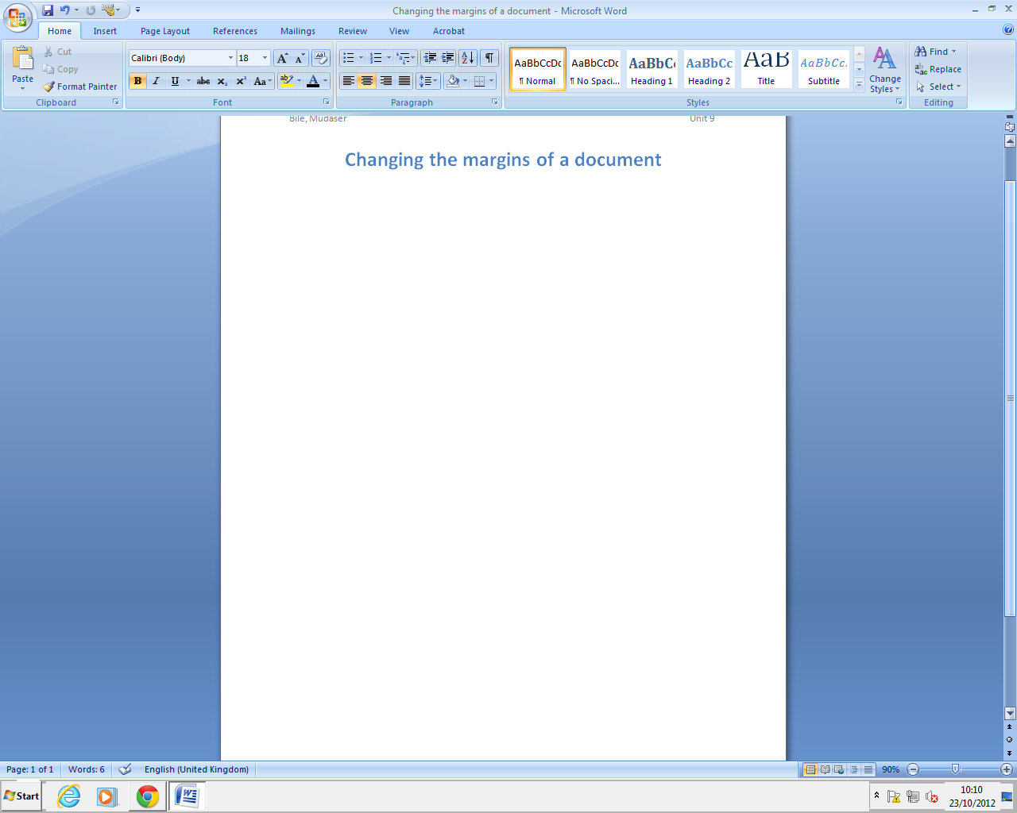
The purpose of the margins is to margins your page normal, narrow and also you can make you page landscape.
This is how the margins first look like

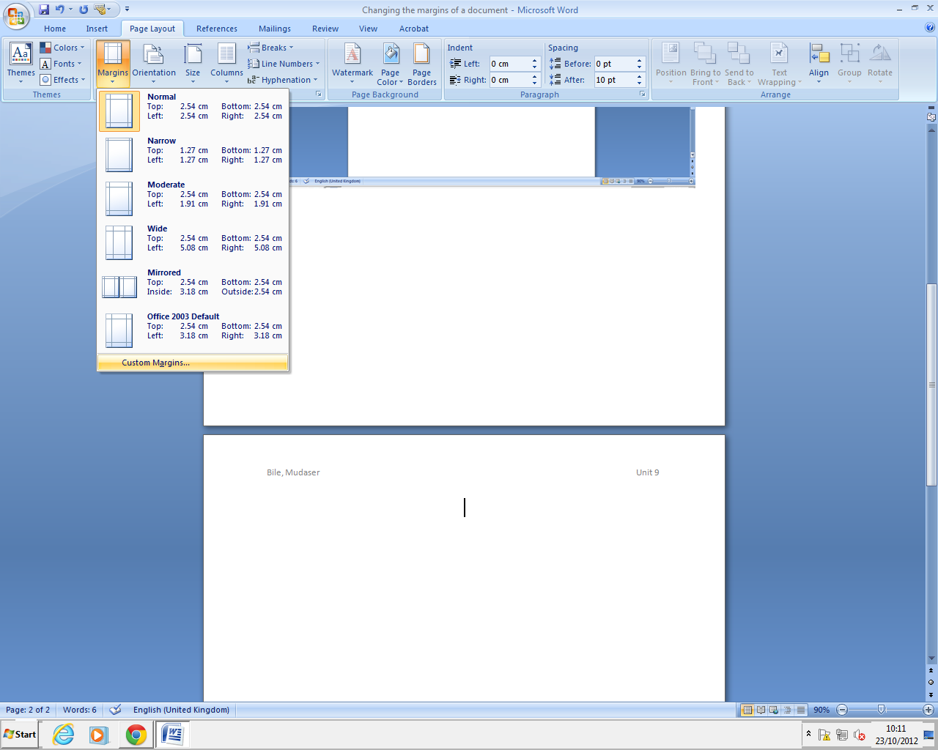
000000
On top tool bar click on “Page Layout” then “margins” and “Custom Margins”
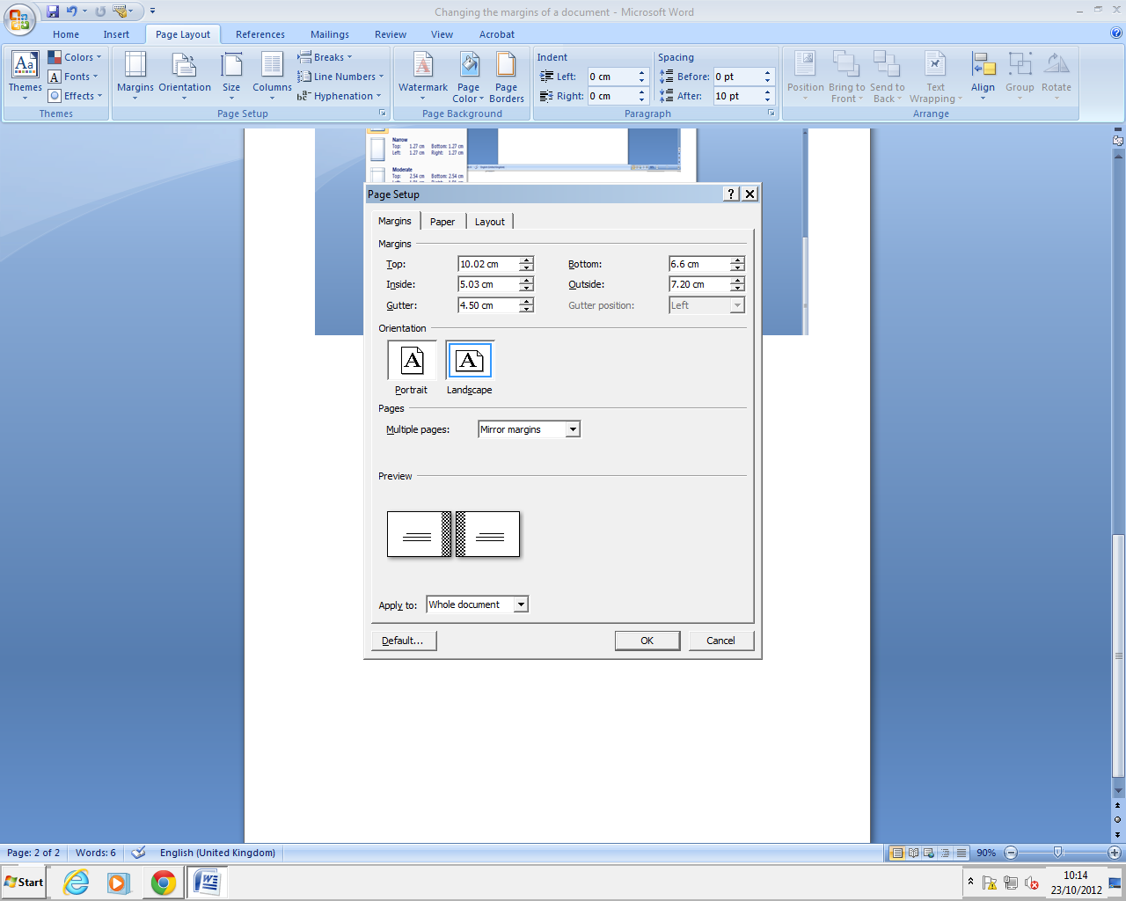
In here you change the margins as you want it to be

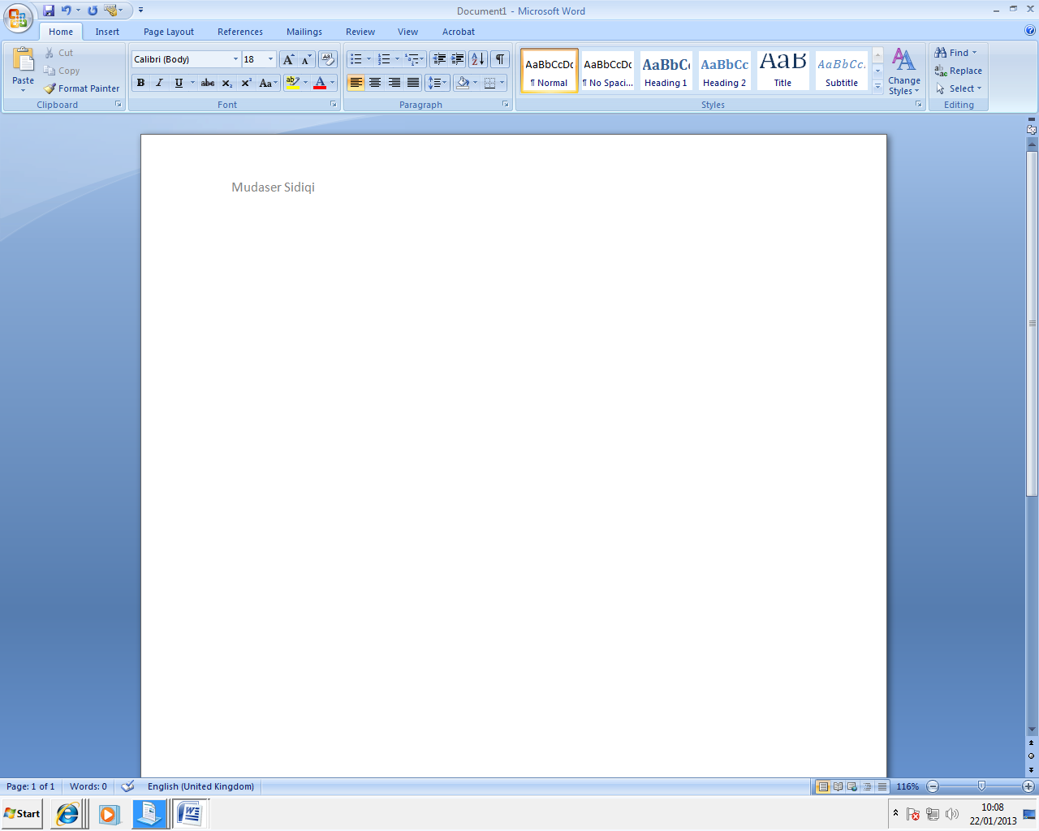
This is how it looked like after the changes were made.

Making a file read only
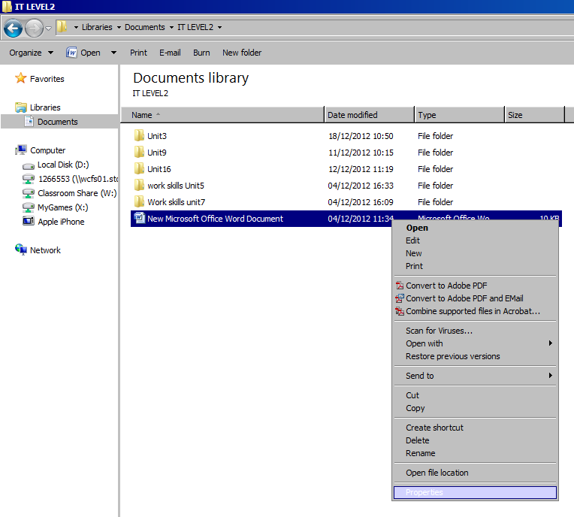
The purpose of the” Making a file read only” is to read only you can’t change words and also you can’t save.

Write Click on the File then press “Properties”

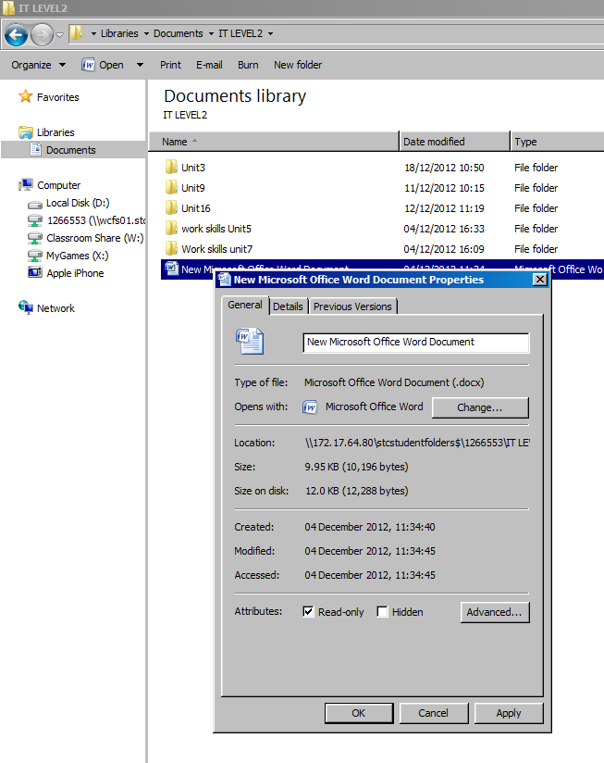

In here make your file read only then press ok

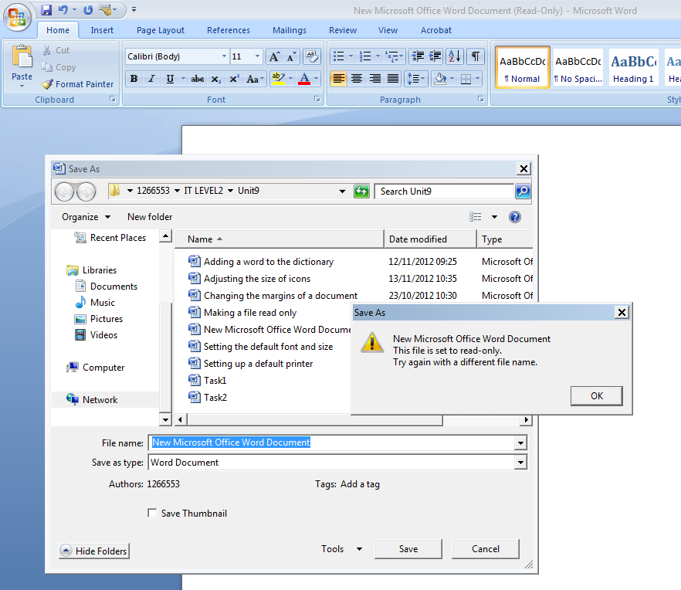

You can’t save as because it’s only “Read Only”

Setting up a default printer
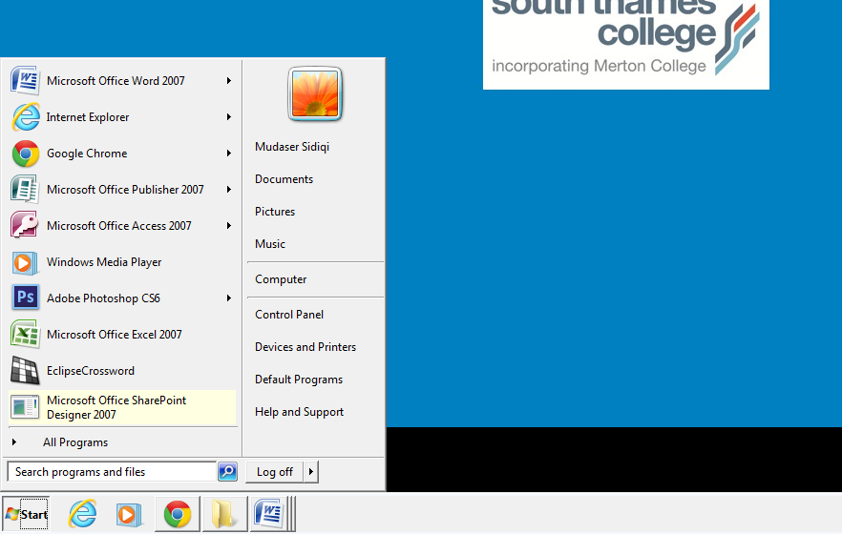
Click on “Start Button”

The purpose of the setting up a default printer is you can connect with different printers.

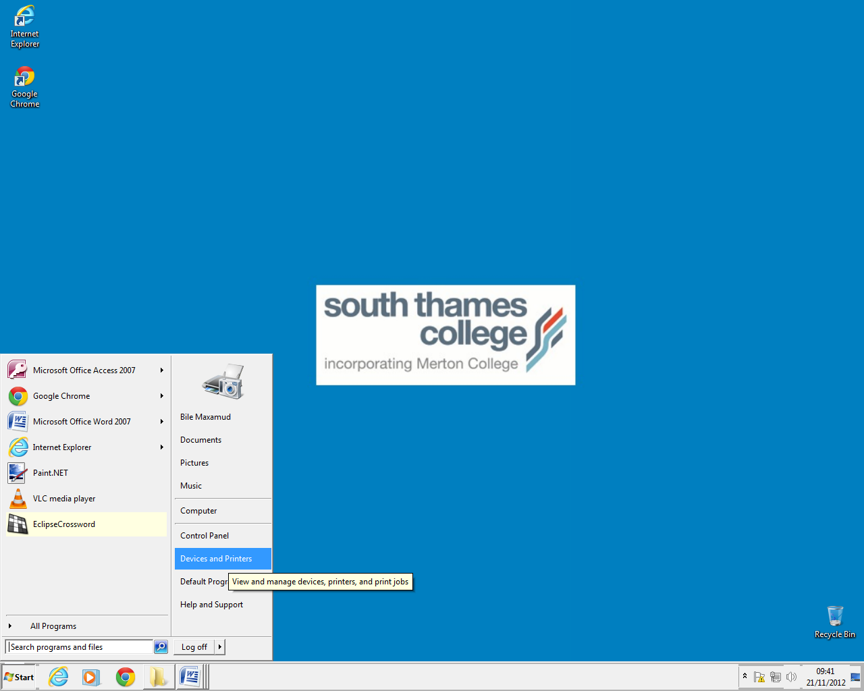
Click on “Control Panel” to open it

Click on Start button then press Devices and printers.

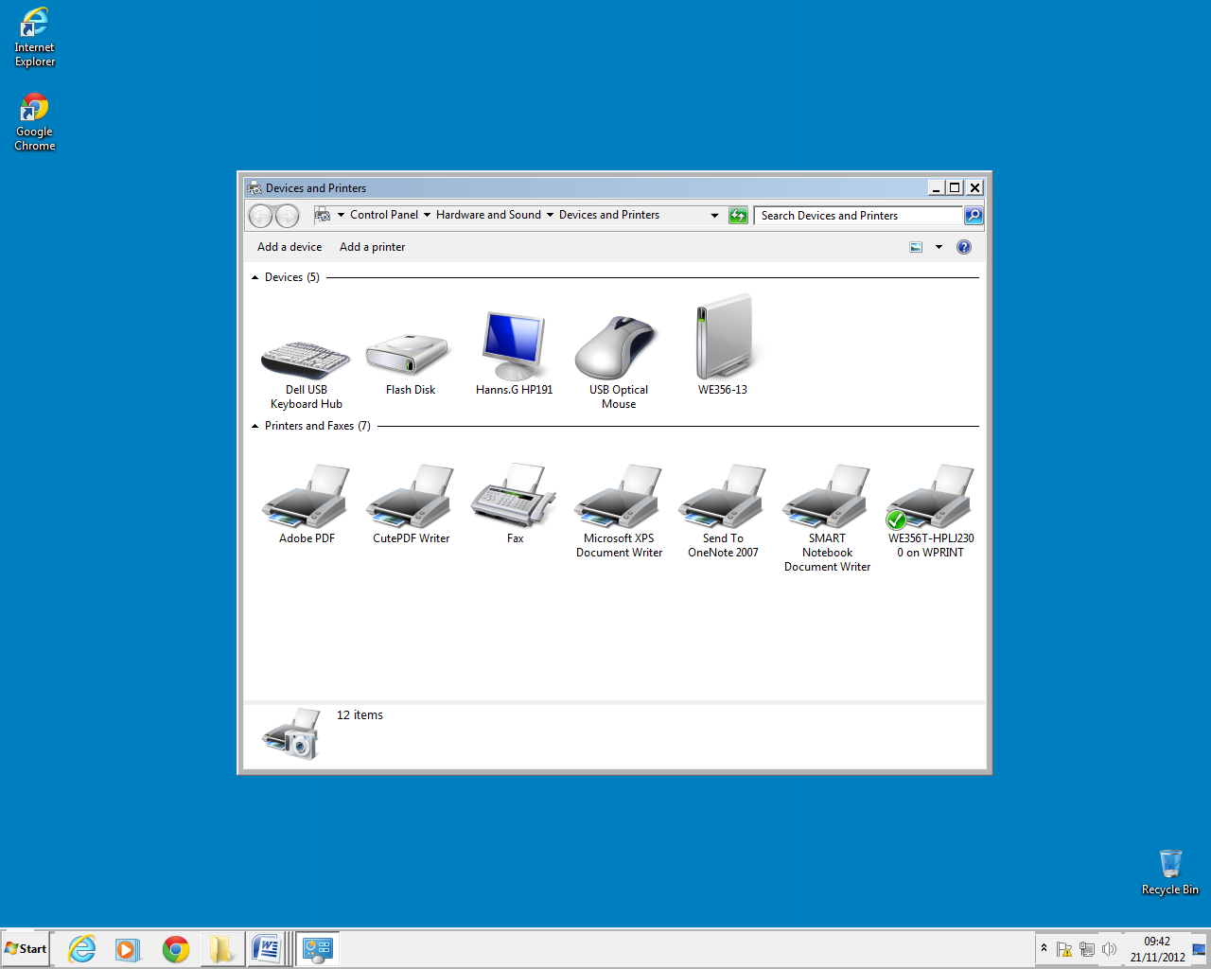
I will be change WE356T printer to Smart printer
This is my default printer now.
Press “start” then “Devices and Printers”

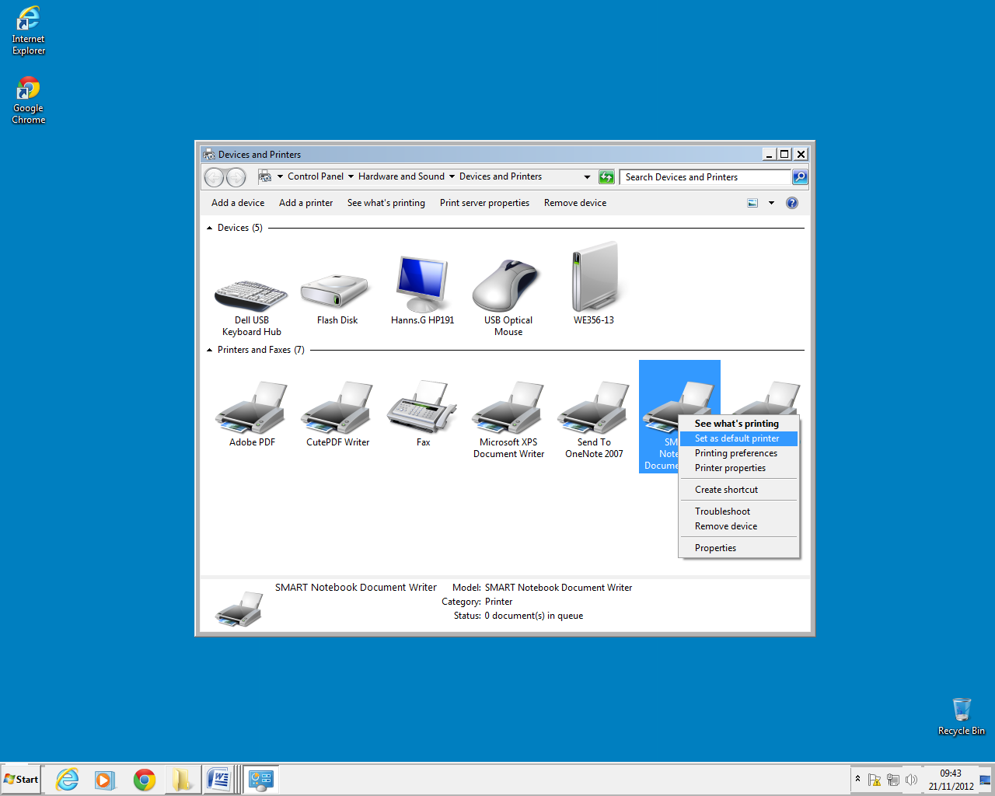
To change default printer to another one, right click on it and click on “Set as default printer.
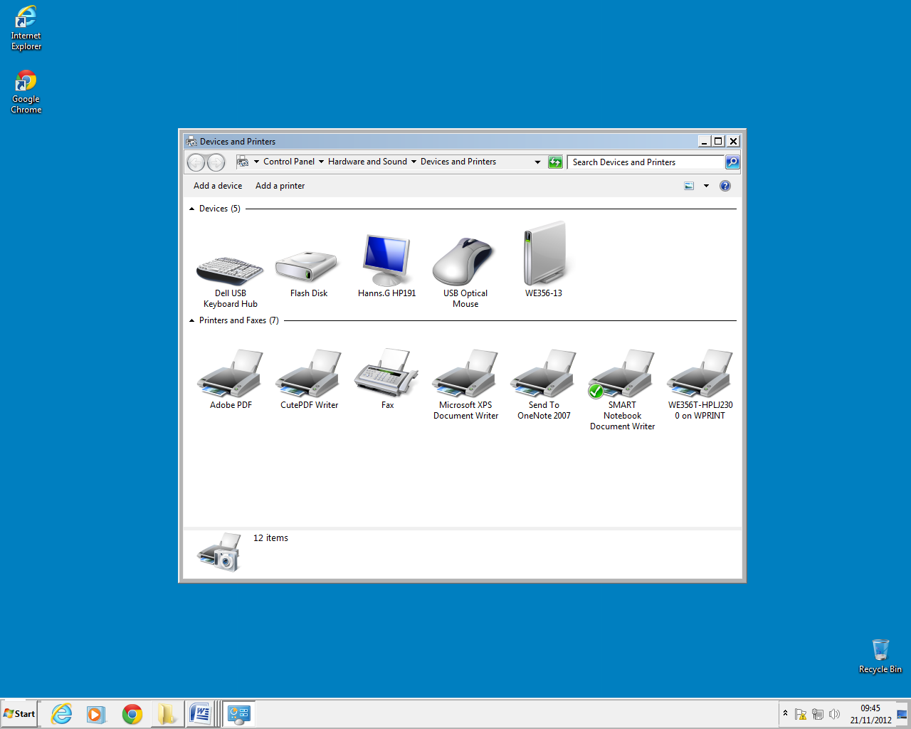
This is my new default printer.

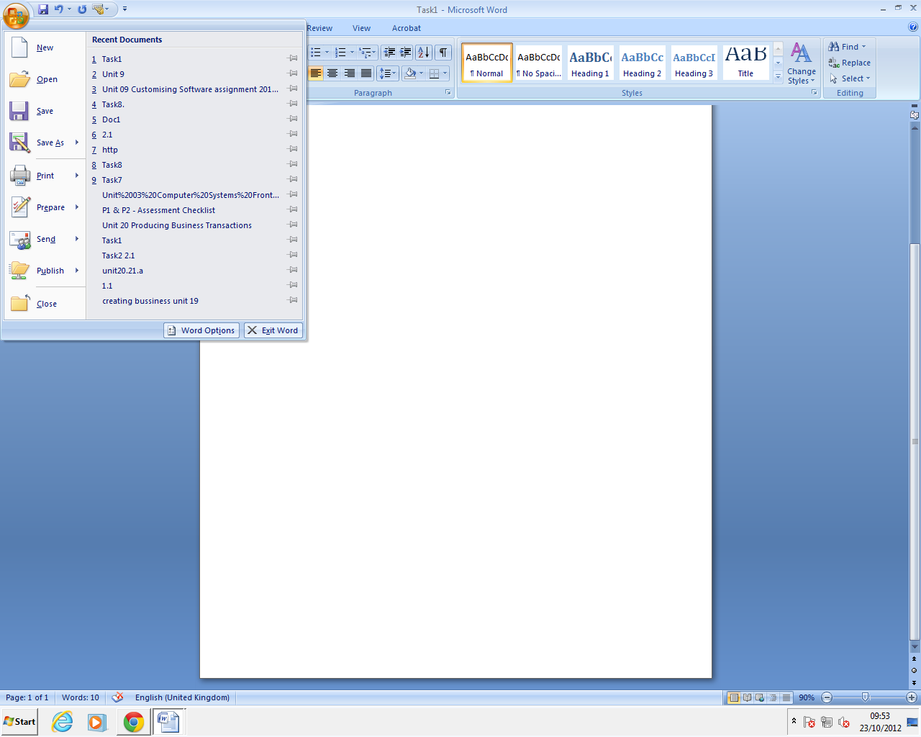
Setting a file to save automatically in to a folder.
Click on “Office button”

The purpose of the Setting a file to save automatically in to a folder is that your files will be automatically saved every ten minutes.

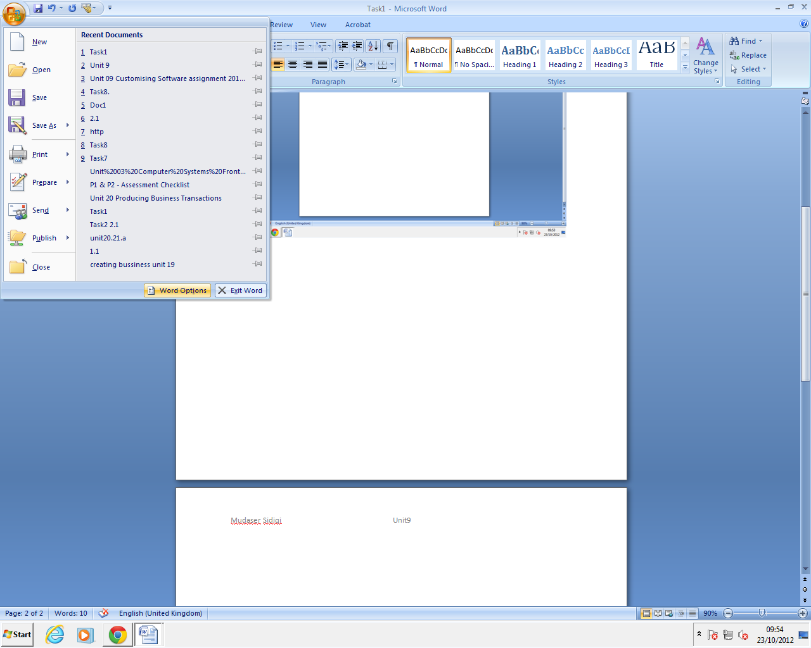
Then click on “World Option”
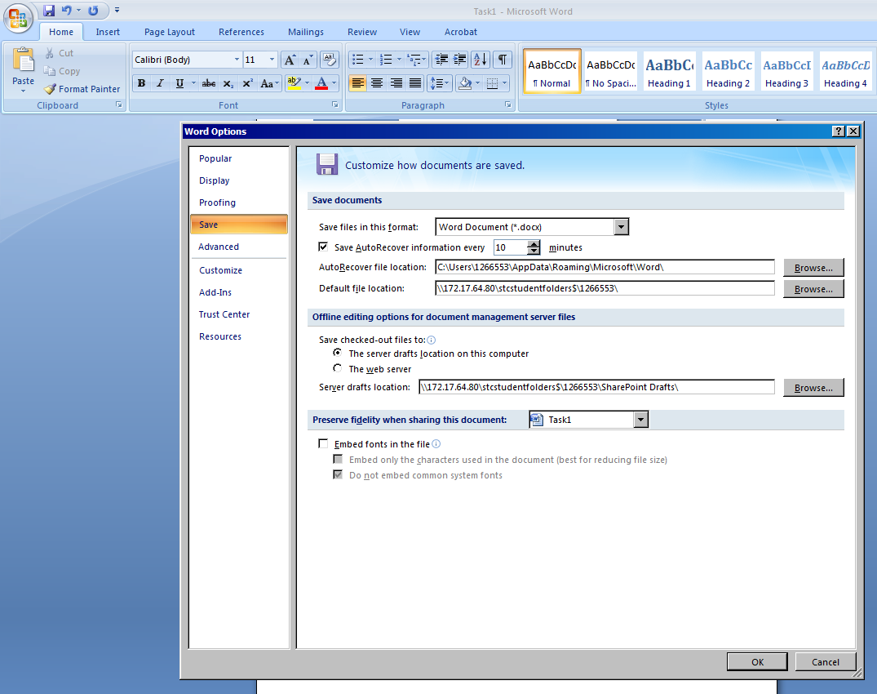
I can decide the min my work will be saved automatically
Click on “Advance”

Press browse on file locations

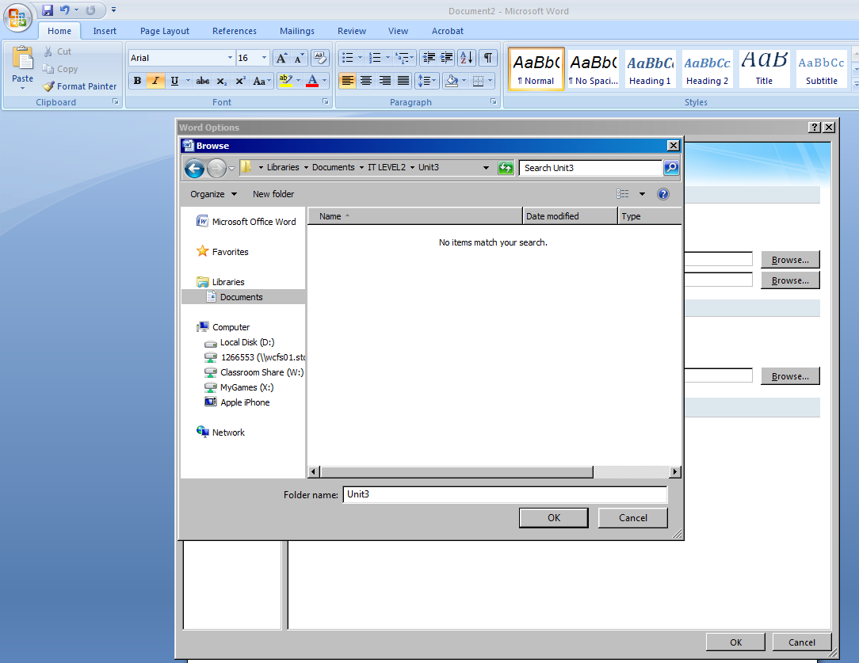

This is my folder I’m going to use

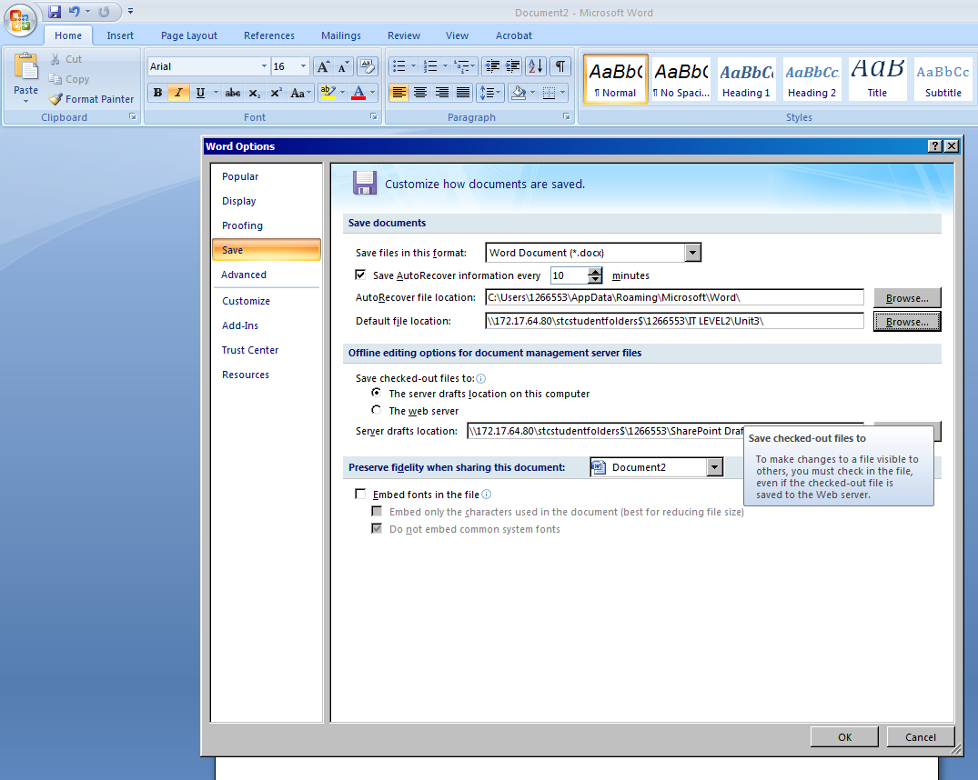
My folder is in the file locations now and to finish this, press OK

Simplifying the toolbar and menu layout.
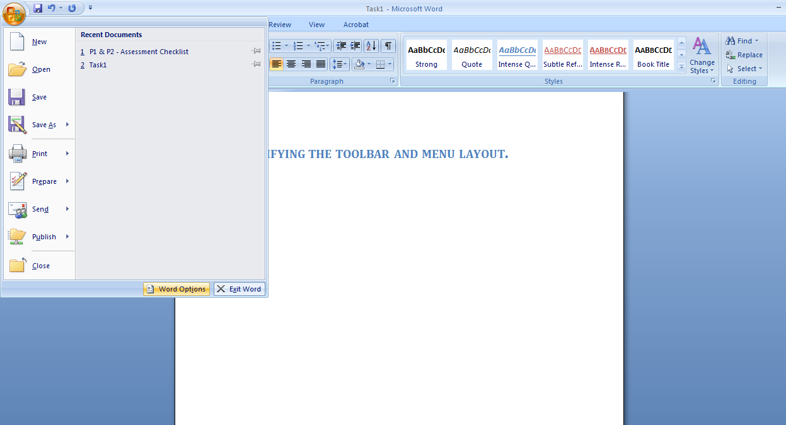
Press start and then click Word option

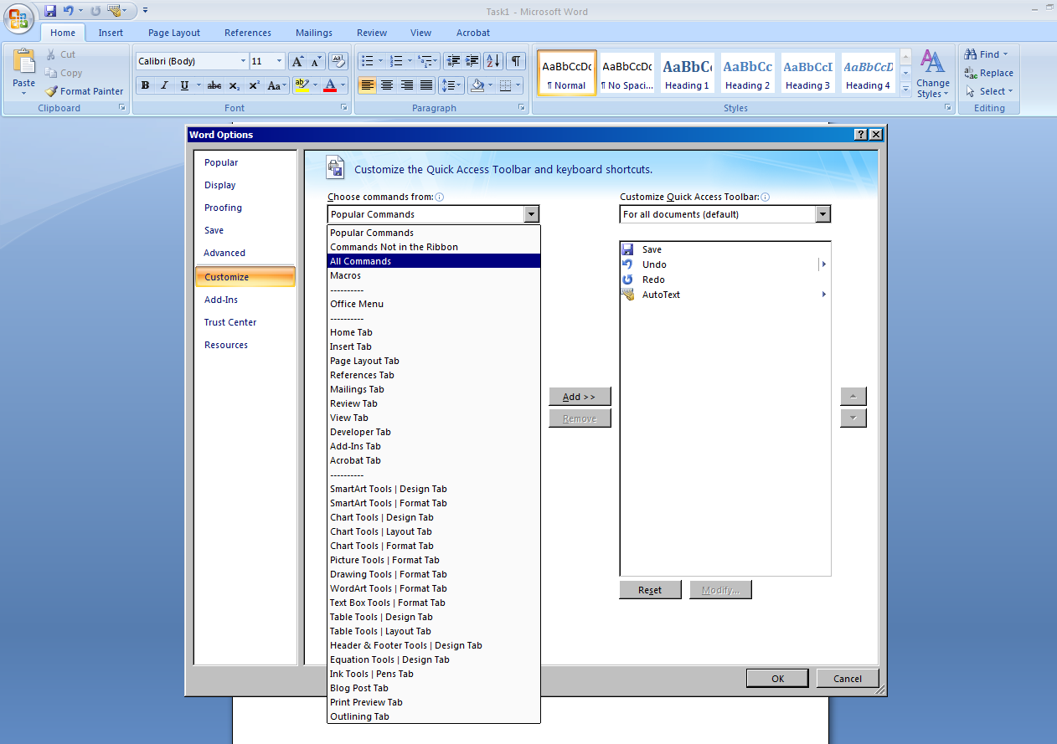
Press Customize then click on all comments then press add

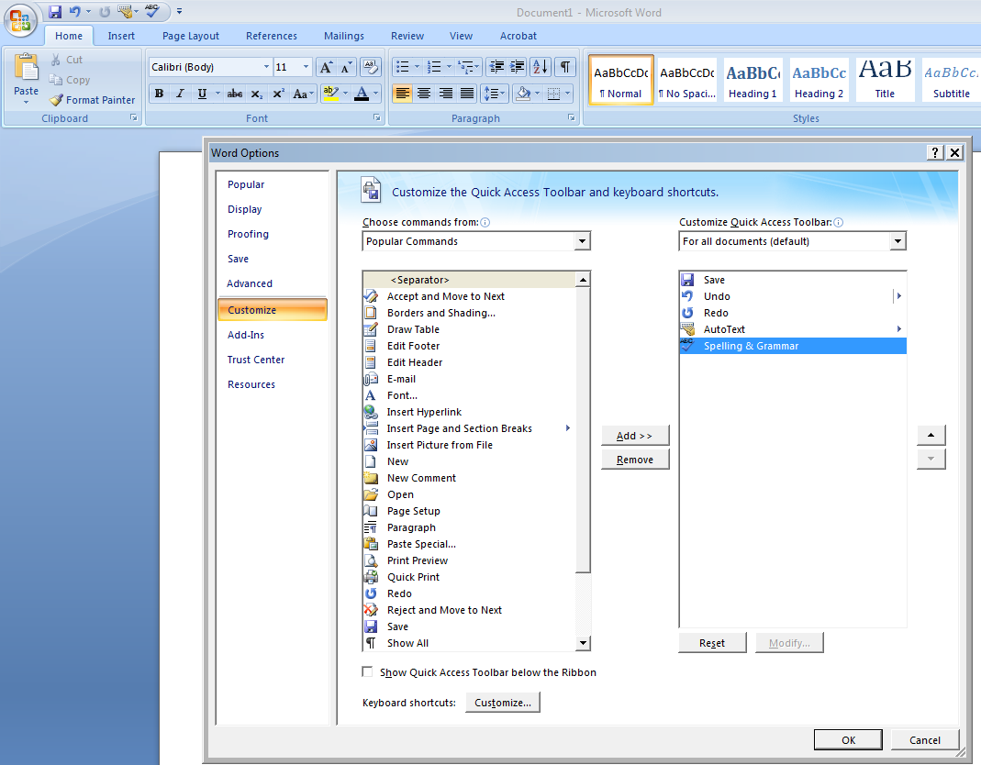

Click on Ok

Here is the result.

